Procurement Management Plan

Group – 6

Team Members:
- Jeevan Bodigam
- Amulya Mallepalli
- Ajay kumar Reddy Arram
- Madhu Babu Konda
- Nagarushyanth Tummala

Date: 6/1/2021

Project Name: Location tracking shoe for kids

Guidelines on Types of Contracts:

Acquisition contracts are contracts to use specific articles and management to tasks. The type of acquisition contract is usually a fixed value, a limitable cost, or a time or a material. Several understanding can be incorporated into an orphanage contract with these payment structures.

The executive acquisition procedure allows you to make workers and correct temporary suppliers of the product for your project. By using the correct supply agreement, several acquisition agreements have an explicit advantage and disadvantages, so it can have a great impact on the prosperity of the project.

Standard procurement documents or templates:

Minor/Low-Risk Contracts: In this type of contract, the association requires the regulator in a short time and the work is often tedious. Then, this type of agreement does not require the first of the strategies of the council.

Major/High-Risk Contracts: Here the type of work is required more and more and more inconvenient and here requires the involvement of complex methods of administration.

Professional: It requires more information-driven capabilities and demands managers willing to invest more time and energy in discovery to meet client standards.

Facilities: More often than not, in this type of governance, redistributed work is the maintenance or operation of an existing structure or framework.

Local/Simple Purchases: Goods are accessible more quickly and there is no longer any need to embark on the purchasing and shipping process.

International/Complex Purchases: For this situation, the products should be purchased in different countries. The administrator's task is slower and slower and an administrative procedure is required for purchasing and shipping. Likewise, the supervisor should investigate customs outside the province.

Guidelines for creating procurement documents:

Procurement documents should contain a large number of reports, which are completed as subtle invitations, subtle requests for quotes, and establishing the terms and status of the deal. The initial quotation of the buyer and the request for concession of the corresponding currency. The data collection and the collection of quotes and suggestions between the two meetings and the dealer's response should also be a procurement document.

- Ask potential bidders to provide full details of the company's evaluation of the bidders.
- All entries must be listed in a reasonable and legal manner to ensure that the basis of the short list is clear.
- The responsibilities, rights and responsibilities of the two meetings in the agreement are clearly defined.
- A clear meaning of the nature and nature of the product or of the administrative management to be given.
- The provisions are not in the interests of either party.
- The language is concise and clear.

Roles and responsibilities:

Roles and Responsibilities
Name and Signature | Role | Position | Contact Information
Jeevan Bodigam  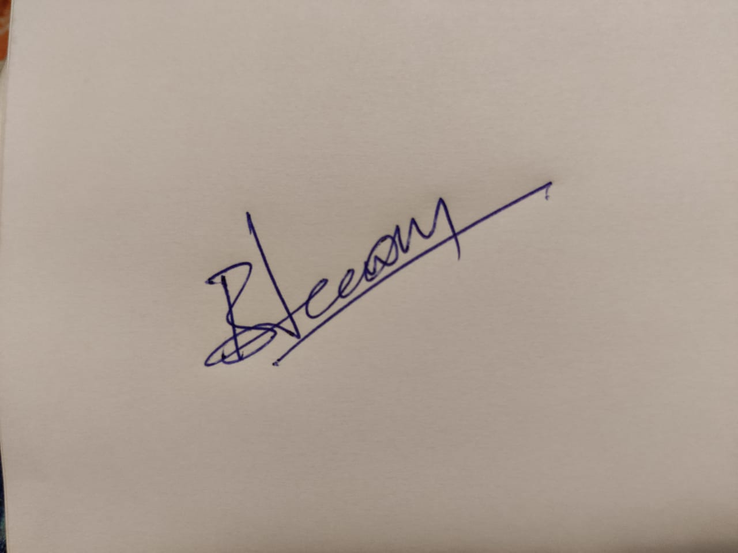 | Project Manager/ Application Developer | Manager | S542039@nwmissouri.edu
Ajay Kumar Reddy Arram  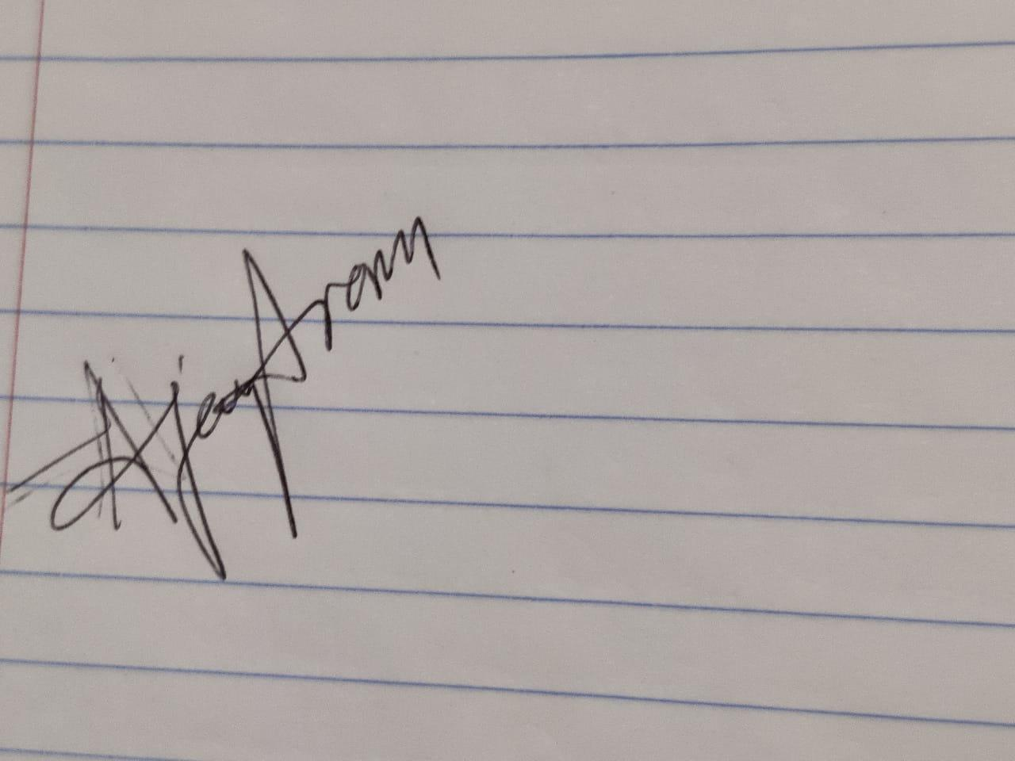 | Test Engineer/Jr. Developer | Team Member | S541989@nwmissouri.edu
Amulya Mallepelli   | Software Developer | Team Member | S542411@nwmissouri.edu
Madhu Babu Konda  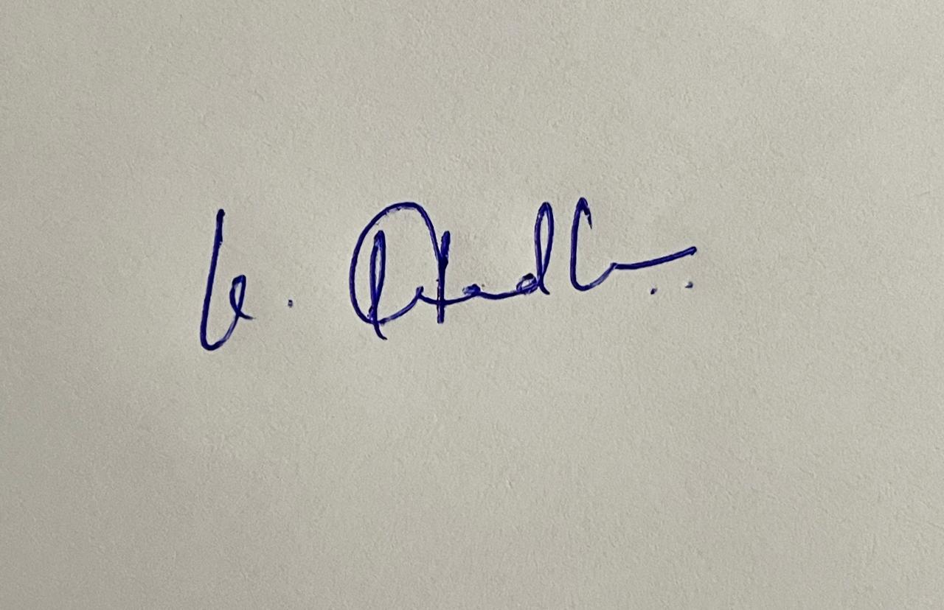 | UI/UX Developer | Team Member | S542311@nwmissouri.edu
Nagarushyanth Tummala  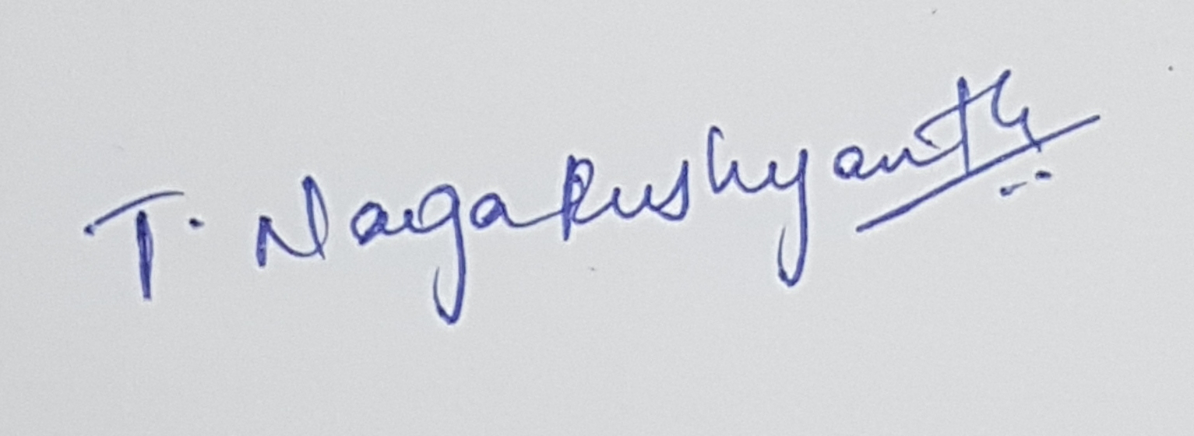 | Sr. Developer | Project Lead | S543652@nwmissouri.edu
Responsibilities:
- Jeevan Bodigam
- Create project schedules and assign tasks to team members
- Arranging team meetings, stand-up meetings
- Analyzing the scope
- Keeping track of all the requirements
- Manage risks Communicating with stakeholders Encouraging and providing guidance to team members
- Nagarushyanth Tummala
- Communicate with team members
- Integrate and coordinate with the tasks
- Motivating the team
- Analyze any challenges faced by team members
- Amulya Mallepelli
- Application backend developer
- Fix security issues
- Create support interface
- Push software updates
- Build coding for application
- Implement navigation system
- Create notification system and alert system
- Madhu Babu Konda
- User interface developer
- Create website for customers
- Integrating GPS system using fluid interfaces ·
- Ajay Kumar Reddy Arram
- Test if GPS trackers functioning properly
- Check if the GPS and Application linked Properly
- Check if Parents and Teachers getting notification properly
- Test performance
- Test quality and comfort of Shoe Perform Quality Assurance

